Nursery Technology Provision:
In Nursery children are introduced to a range of technology and how it used. This lays the foundations for the Reception year
Experiences | Children will know
Touchscreen used for children to independently access programmes. | I know that I can move things on the screen by dragging  I know that I can click on something and it will generate response.  I know that technology can create and show images, video and sound.
Coding Critters are used in Key person time and then in Provison. In provision they are then supported through the SHREc approach with staff modelling eg routes linked to maths | I know that I can use buttons to make the coding critters move forwards and backwards. I can use and understand vocab such as ‘Instructions’
3 ipads used with apps such as beebots and coding safari reinforcing as above | I know that I can use buttons to make the coding critters move forwards and backwards. I can use and understand vocab such as ‘Instructions’ ad directional words  I know to tell an adult if I see something I am not sure of or I am stuck.
Programming is also developed through the sensory eggs eg using the remote to change to light colour, turning the light panel off and on. | I know that the remote control changes the colours of the sensory eggs.  I know what the on and off buttons do.

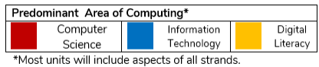
Reception Technology Planning and progression Updated Sep 25
 | Autumn 1 | Autumn 2 | Spring 1 | Spring 2 | Summer 1 | Summer 2
Barefoot unplugged Computational Thinking | CS; Barefoot Computing: Awesome Autumn  I know about and can identify the patterns around me. For example: stripes on clothes,  designs on rugs and wallpaper. Extend and create ABAB patterns – stick, leaf, stick, leaf. I can notice and  correct an error in a repeating pattern.  I know how to continue, copy and create repeating patterns.  I know and can use words like ‘in front of’ and ‘behind | CS; Barefoot Computing:  Busy Bodies  I can about me bodies including the similarities and differences in relation to each other, the  effect of emotions, physical activity.  I am inquisitive about how  my body works | CS; Barefoot Computing:  People Who help us  I name and describe people who are familiar to me.  I can draw information from a simple map.  I can continue, copy and create repeating patterns  I can make patterns with varying rules (including AB, ABB and ABBC) and objects and invite children to continue the pattern.  NB:Abstraction is the skill of being able toignore what is not important, and beingable to focus on what is important | CS; Barefoot Computing:  Spring Time  I understand the need to respect and care for the natural environment and all living things.  I know the effect of changing seasons on the natural world around me.  I know how collaborating with others to solve a problem – in this case, planning a way to help the rabbit get to the carrots it needs. | CS; Barefoot Computing:  Summer Fun  I can use talk to help work out problems and organise thinking and activities, and to explain how things work and why they might happen.  I know how shapes can be placed together to form a picture called a tangram. I know how to combine, turn and place shapes to create familiar seaside features. | CS; Barefoot Computing:  Boats  I can use talk to help work out problems and organise thinking and activities, and to explain how things work and why they might happen.  I know how shapes can be placed together to form a picture called a tangram. I know how to combine, turn and place shapes to create familiar seaside features.
Information Technology/Digital Literacy | DL Mouse and touch screen skills  To know how to use a laptop touchpad  To be able to use click and drag to move objects purposefully.  To be able to move the mouse purposefully.  I can use a mouse to make the cursor move around the computer screen where I want it to go.  To know how to move and click on objects on an ipad | DL Keyboard skills  I know what a keyboard looks like on a laptop and on an ipad.  I can find letters of my name on the alphabet on a keyboard.  I can put spaces between words in my typed work  I know that the back space key deletes my typing.  I can log in to purple mash and doodle maths | IT Drawing skills  I know I can use a laptop or ipad to draw  I can use 2paint to draw a simple picture on either an ipad or a laptop  I can try the different tools that I can draw with on the computer.  I can use the undo button correctly.  I can use the erase button.  I can use a touchscreen device purposefully. | CS Robots  I can talk about where I am moving a toy vehicle whilst I am moving it.  I know how to follow simple direction instructions using forward, backwards, turn, left and right  I can describe the route taken by a toy vehicle.  I can program a 3-step route for a floor robot or online toy | DL Sounds  I know I can use the laptop and ipad to make sounds.  I can make sounds on a laptop or ipads using 2beat, garage band or 2explore  I can use a device to record myself speaking and play back the sounds. (mashcam) | IT Photography  I know what a photo is and that is a printed image not a drawing.  I can take photos using a digital device eg KITT or an ipad.  I know that I need to ask for consent to take a photo of a person.  Introduction to quizzs  I Know what a quiz is.  I can complete a simple quiz.  I can type answers to a quiz.  I can sequence pictures in a quiz.
 | CS Computational Thinking  I can follow simple oral algorithms  I can spot simple patterns  I can sequence simple familiar tasks | CS Computational Thinking  I can follow simple oral algorithms  I can spot simple patterns  I can sequence simple familiar tasks | CS Computational Thinking  I can follow simple oral algorithms  I can spot simple patterns  I can sequence simple familiar tasks | CS Computational Thinking  I can follow simple oral algorithms  I can spot simple patterns  I can sequence simple familiar tasks | CS Computational Thinking  I can follow simple oral algorithms  I can spot simple patterns | CS Computational Thinking  I can follow simple oral algorithms  I can spot simple patterns  I can sequence simple familiar tasks
Resources introduced and revisited in continuous provision including KITT robots, Codapillars, Easiscopes, Metal detectors
I can talk about what technology is used at home. I can talk about what technology is used outdoors. I can talk about what technology is used in the world around me.

Direct Adult Teaching

 | Core Knowledge | Key teaching points | Resources | Key vocabularly
Autumn 1 | CS; Barefoot Computing: Awesome Autumn  I know about and can identify the patterns around me. For example: stripes on clothes,  designs on rugs and wallpaper. Extend and create ABAB patterns – stick, leaf, stick, leaf. I can notice and  correct an error in a repeating pattern.  I know how to continue, copy and create repeating patterns.  I know and can use words like ‘in front of’ and ‘behind  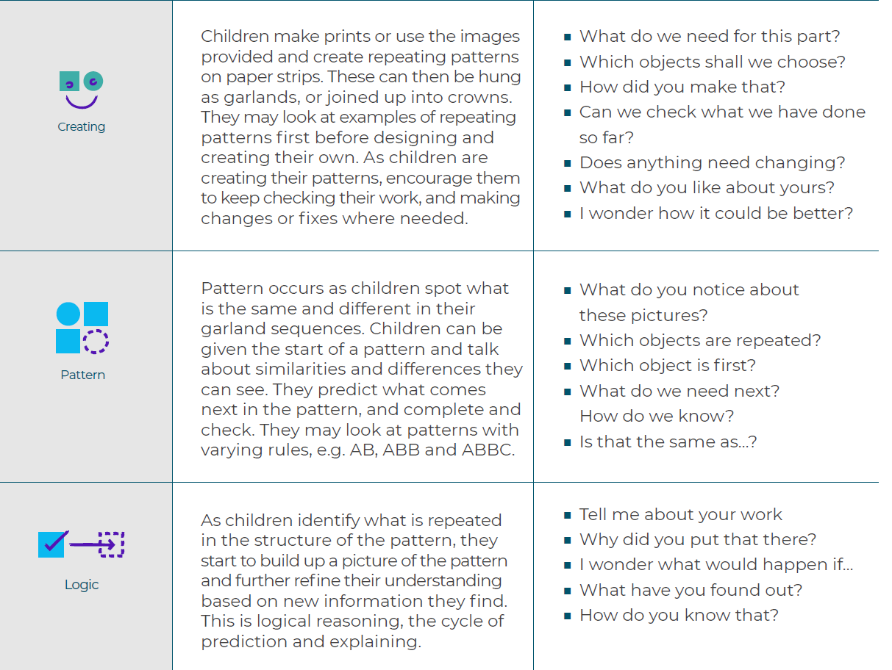  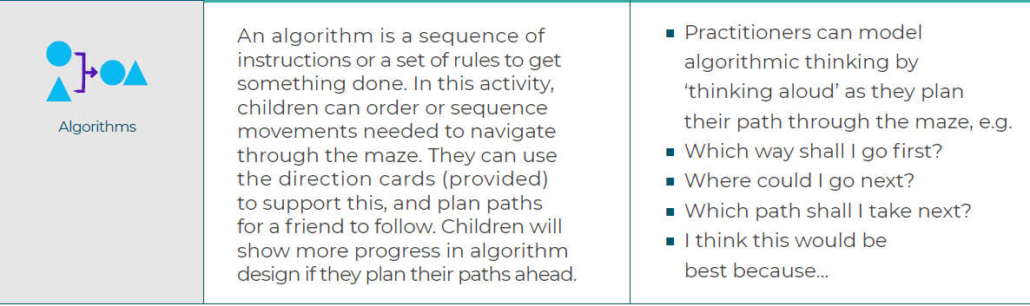  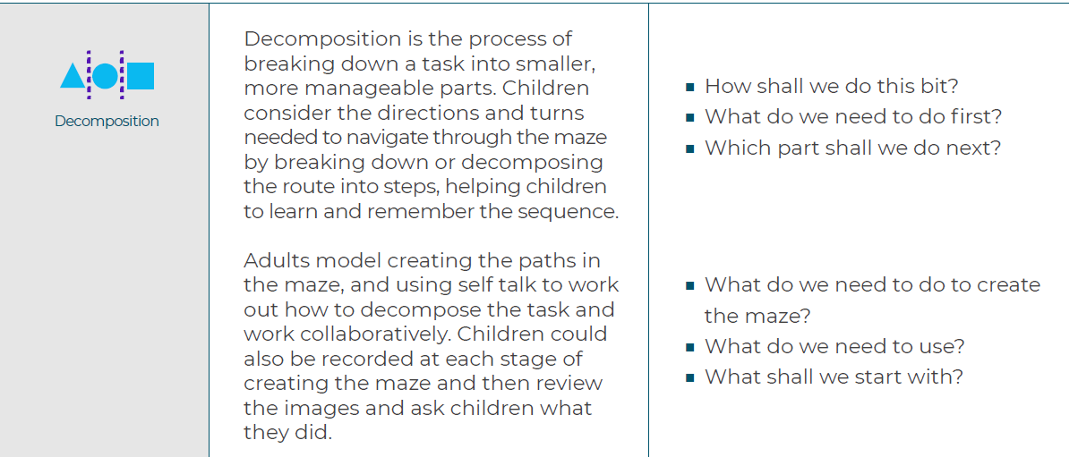 | Garlands:  Children: Talk about the patterns they can see in a sequence and continue a given pattern.  They spot mistakes in patterns and fix them.  Adults: Provide an opportunity to look at a range of patterns in the environment and question children  about the similarities and differences in them.  Leaf labyrinth:  Model how to complete patterns which have been  started. Model creating patterns containing deliberate mistakes, and then model the process of  checking, finding and fixing those errors.  Pumpkin Soup:  In this activity, children learn about the process of making pumpkin soup. They look at images of the  steps involved in making the soup, and sequence them so that they make sense. They follow their pictorial  recipes to create the pumpkin soup. The activity plan and resources are based on a soup recipe, but could  be easily adapted to any recipe which fits your theme. | Long strips of paper  ■ Autumn objects  ■ Paint for printing  ■ Autumn garlands worksheet (provided)  ■ Scissors  ■ Glue  Piles of leaves – these can be collected with the children on a local walk  ■ Treasure, e.g. a bag of conkers, also collected on a walk  ■ Cones / blocks / sticks for further maze creation  ■ Vehicles or small characters to travel through the mazes (optional)  ■ Vocabulary cards (provided) | Identify on Medium Term plan
Autumn 1 | DL Mouse and touch screen skills  I know how to use a laptop touchpad  I am able to use click and drag to move objects purposefully.  I am able to move the mouse purposefully.  I can use a mouse to make the cursor move around the computer screen where I want it to go.  I know how to move and click on objects on an ipad | Introduce what a laptop is and name the parts  keyboard, screen touchpad also called a mouse  Introduce an ipad and name, sometimes called a tablet. Touchscreen  On the laptop encourage use of two pointy fingers. Left hand to click the left button and right hand to move the mouse. | Simple city: moving images using click and drag. | Laptop  Screen  touchscreen  keyboard  Mouse  Pointer  Click  Drag  Back  Log in
Autumn 2 | CS; Barefoot Computing: Busy Bodies  I can about me bodies including the similarities and differences in relation to each other, the  effect of emotions, physical activity.  I am inquisitive about how  my body works  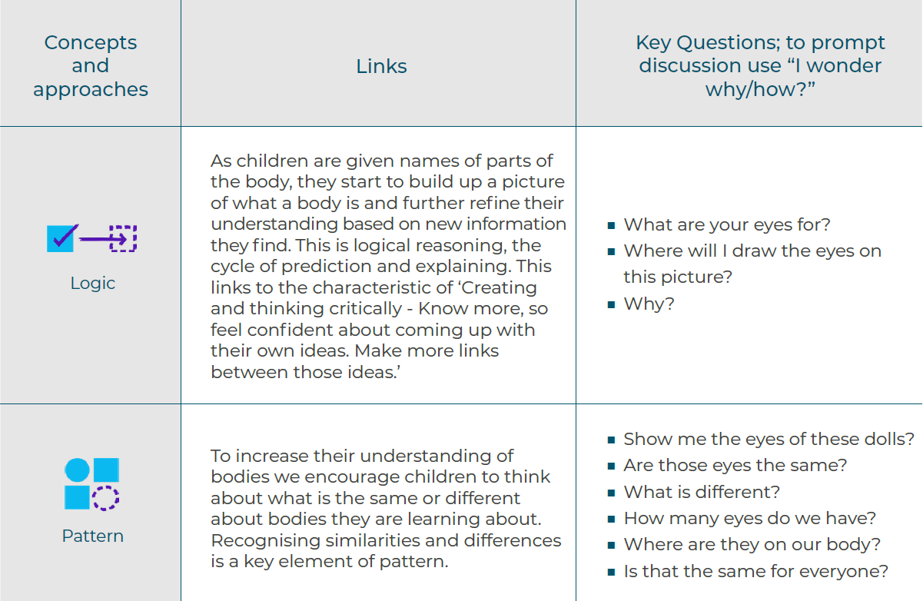  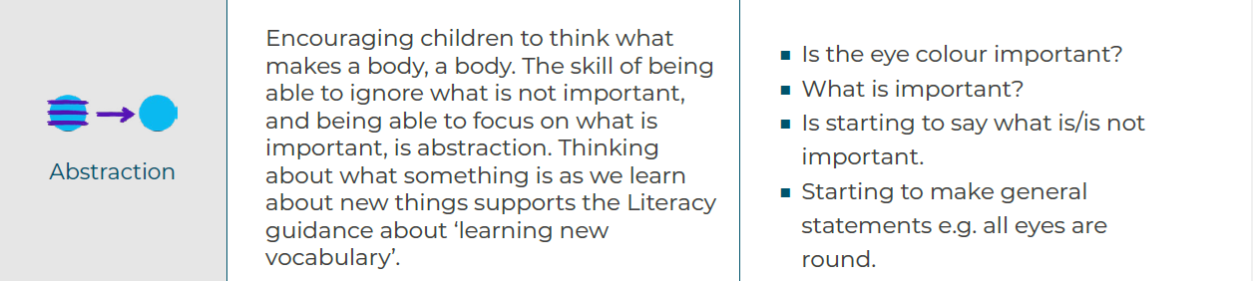 | Parts of our body  In this activity children find out about the human body from a range of sources, such as observation of  their own bodies, looking at books, watching film clips, listening to stories, singing songs about bodies  and role play.  Make a body  In this activity children create representations of a body by making pictures and models.  Children might do the ‘making’  independently based on example models or follow verbal or pictorial instructions.  Look how we grow  In this activity, as children learn about growth, they notice the different stages of growth and put  these stages in order.  Movement algorithms.  In this activity children follow instructions (an algorithm) for a simple set of movements or dance routine.  They then adapt and change this to make their own routine and test to see if it works. | Books/images about bodies
Autumn 2 | DL Keyboard skills  I know what a keyboard looks like on a laptop and on an ipad.  I can find letters of my name on the alphabet on a keyboard.  I can put spaces between words in my typed work  I know that the back space key deletes my typing.  I can log in to purple mash and doodle maths | Recap parts of a laptop and an ipad.  Focus on the keyboard on both devices. Model how to use the keys to type your name in lower case initially and model how to erase using the back space key.  Move on to introduce the enter key to move down a line and then type your name again  Type your name to log into purple mash and doodle maths. | Purple mash 2write | Keyboard  Key  Back space  Type  Letters  Enter
Spring 1 | CS; Barefoot Computing: People who help us  I name and describe people who are familiar to me.  I can draw information from a simple map.  I can continue, copy and create repeating patterns  I can make patterns with varying rules (including AB, ABB and ABBC) and objects and invite children to continue the pattern.  NB:Abstraction is the skill of being able toignore what is not important, and beingable to focus on what is important  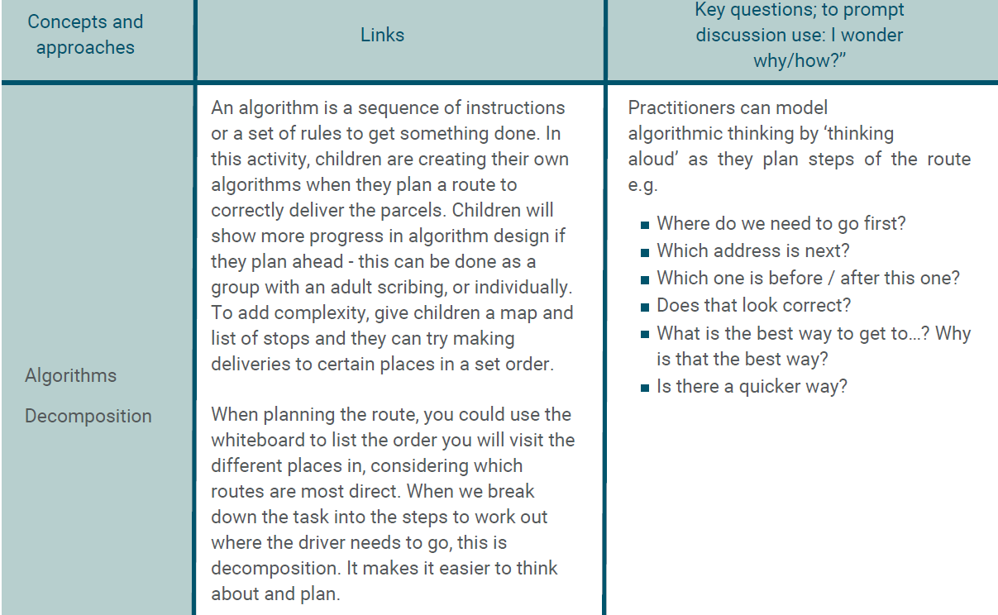  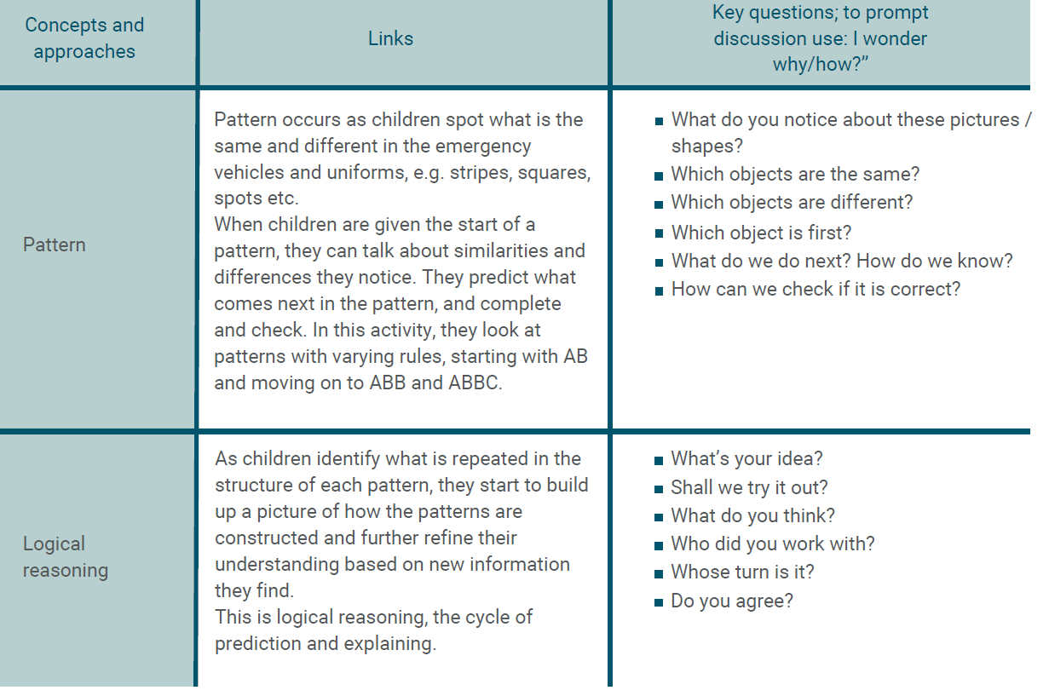 | Delivery:  In this activity, children take on the role of a delivery driver as they work together to deliver parcels to destinations on a map.  Pattern patrol:  In this activity, children spot patterns in the design of emergency vehicles and uniforms and then create their owndesign. stripes, squares, symbols, bright colours etc.  They continue the provided partially completed patterns and can then create their own emergency vehicle designs,incorporating pattern into them.  Firefighter  In this activity, children work in small groups to design uniforms for a firefighter. They start by looking at images ofa range of firefighters in different uniforms to find out which main features all the uniforms have in common. Thishelps them plan what they need to include in their own designs | Map printable (one has been provided, or create your own)  Delivery vehicle printable (provided) or small world van / truck toy  Address labels printable (provided, or create your own linked to your map)  Small world people / props to use as parcels to add to your map  Mini whiteboards and pens
Spring 1 | IT Drawing skills  I know I can use a laptop or ipad to draw  I can use 2paint to draw a simple picture on either an ipad or a laptop  I can try the different tools that I can draw with on the computer.  I can use the undo button correctly.  I can use the erase button.  I can use a touchscreen device purposefully. | Set up as a 2do.  Leave 2paint open in provsion  Recap parts of a laptop and an ipad and how to logon to purple mash.  Introduce how 2paint can be used to create and print a picture. Introduce:  -How to take the top off a pen and click and drag to make a mark  -How to select another colour  How to use the ‘undo’ button  -How to choose the ‘erase’ tool.  How to use the ‘Abc to type your name  How to save and exit | Purple mash 2 paint | Laptop  Screen  touchscreen  keyboard  Mouse  Pointer  Click  Drag  Back  Log in  Select  Undo  erase
Spring 2 | CS; Barefoot Computing  I understand the need to respect and care for the natural environment and all living things.  I know the effect of changing seasons on the natural world around me.  I know how collaborating with others to solve a problem – in this case, planning a way to help the rabbit get to the carrots it needs.  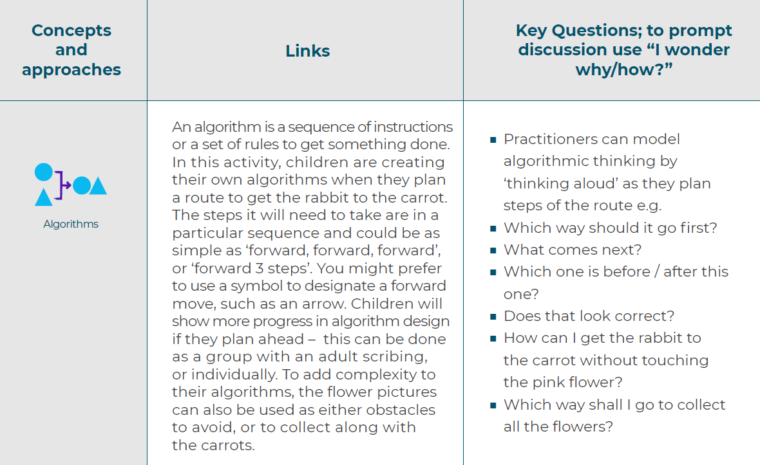  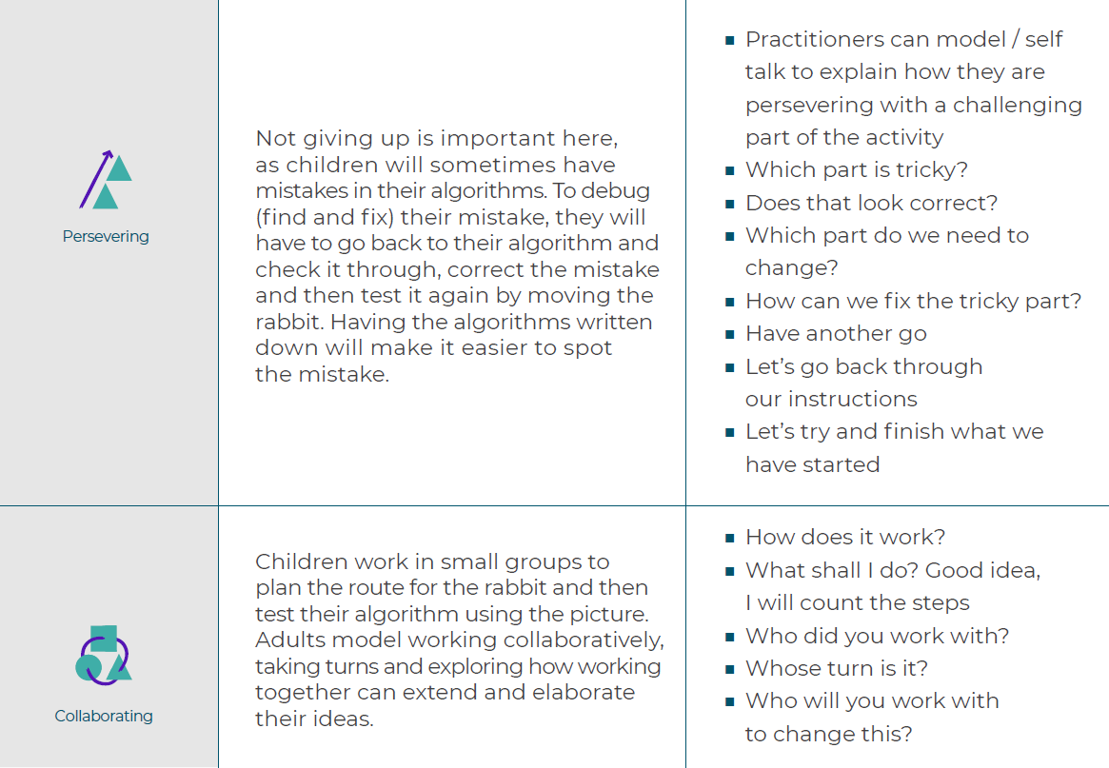 | Scarecrow  children work in small groups to create a scarecrow from junk materials. They start by  looking at pictures of scarecrows to find out which main features all scarecrows have in common.  This helps them plan what they need to include in their own scarecrows. They draw pictures of a scarecrow  including the main features (e.g. head, hat, shirt, straw etc.), adding labels if appropriate. They then work  together to create a scarecrow, incorporating the main features identified  Rabbit Run  In this activity, children give instructions to direct a rabbit around a grid and collect carrots. These instructions  can be written down using symbols, words or numbers, which creates an algorithm, or a set of instructions.  Children work in small groups to plan their routes and then test their algorithms using the rabbit print-out  Seed Sequencing  The children begin by looking at pictures of the steps involved  in planting seeds (provided). They then sequence the pictures so that they make sense and are in the  correct order. Next, they follow their pictorial instructions to plant their seeds.
Spring 2 | CS Robots  I can talk about where I am moving a toy vehicle whilst I am moving it.  I know how to follow simple direction instructions using forward, backwards, turn, left and right  I can describe the route taken by a toy vehicle.  I can program a 3-step route for a floor robot or online toy | Unplugged work first to introduce simple directional instructions.  Introduce 2go (through minimash)  Use the arrow keys to move the bee to a flower and talk about the movements using the key vocab. Children can try and take the bee to each flower using the arrows and change the colour of the route.  On the ipads introduce the beebot app. Work up to level 3 where children need to use 3 instructions to move the bee.  Programms like coding safari and daisy the dinosaur can then be used in provision where children move tiles to create the route | 2go  Beebots  Coding safari | Instructions  Forwards  Backwards  Left  Right  Turn  arrow  Route  Flower  Bee
Summer 1 | CS; Barefoot Computing  I can follow 2 and 3 part instructions  I can talk about the differences between materials and changes  they notice.  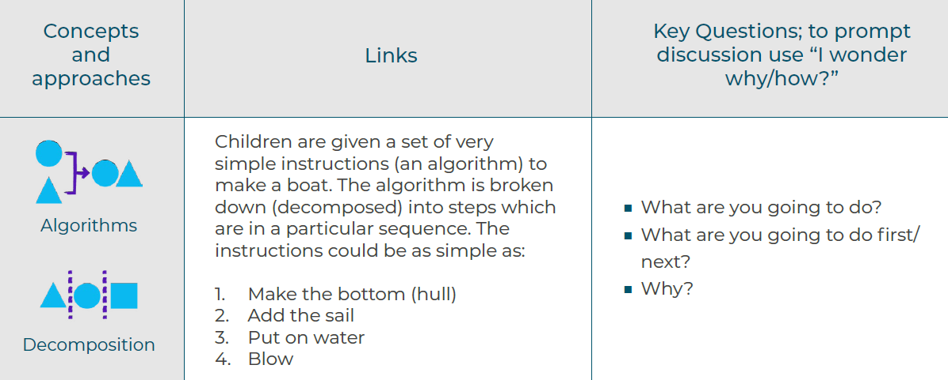  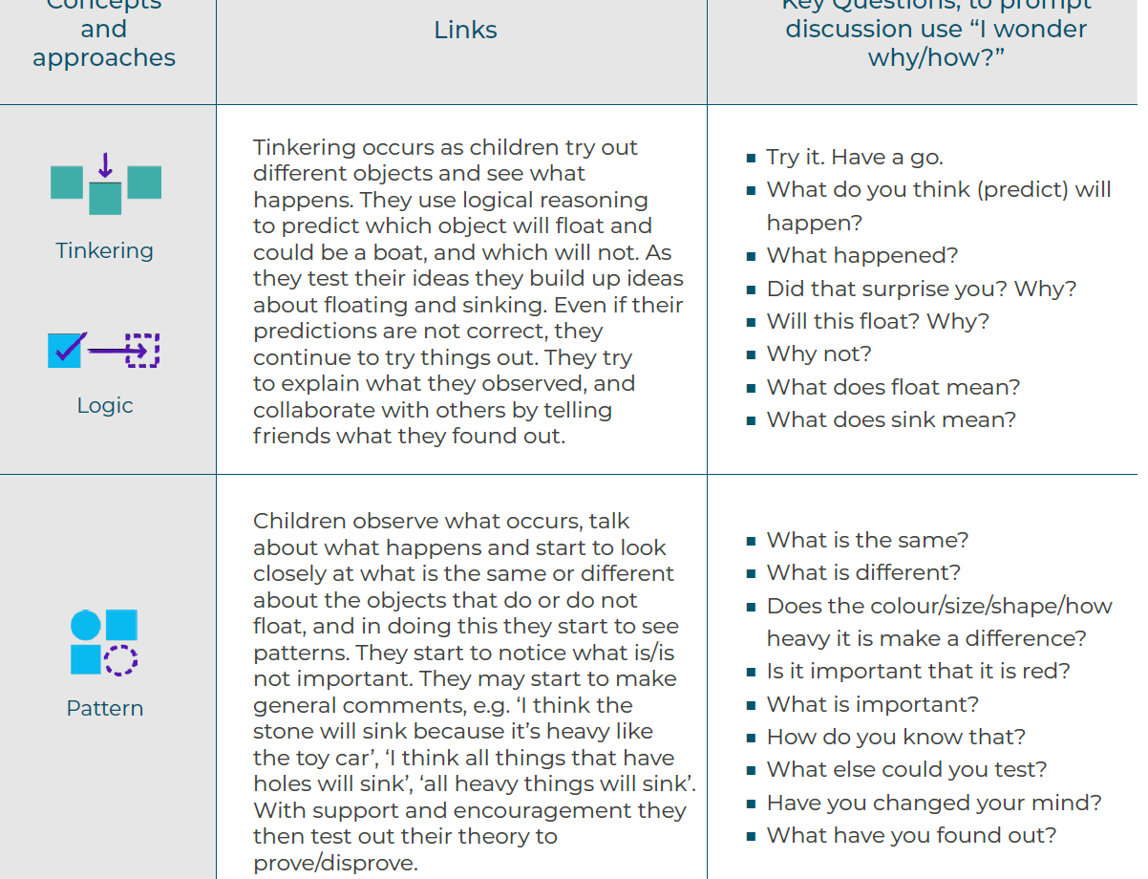 | What is a boat  In this activity children find out about boats from a range of sources, such as their families talking about  experiences of boats, looking at books, watching film clips, listening to stories, singing songs about boats  and role play. There are IT skills here in the use of technology as children find out about things and  interact with software. There are also clear opportunities for the early learning goals of reading as they  read from a range of sources  Build a boat  In this activity children follow instructions to make a simple boat and test to see if it works. They then  create their own designs for a boat.  Is this a good boat?  In this activity, children explore floating and sinking by placing different objects in a water tray. Children  predict which objects would sink or float and test their predictions. Adults could place the objects into  trays once they have been tested, and label them ‘float’ and ‘sink’. They could also record the results in a  simple table, into which children could draw the objects
Summer 1 | Sounds  I know I can use the laptop and ipad to make sounds.  I can make sounds on a laptop or ipads using 2beat, garage band or 2explore  I can use a device to record myself speaking and play back the sounds. (mashcam) | 2 explore  Recap parts of laptops and ipads and key vocab.  Introduce that we can make and record sounds and voices on ipads on laptops, ipads and other devices.  Show and allow children how to create a sequence of sounds and record them in 2 explore.  Show children how they can record voices on KITT and play back. This can also be done on mashcams. | Ipad use purple mash 2explore  Laptop: 2 explore  KITT robots | Sound  Record  Play
Summer 2 | CS; Barefoot Computing  I can use talk to help work out problems and organise thinking and activities, and to explain how things work and why they might happen.  I know how shapes can be placed together to form a picture called a tangram. I know how to combine, turn and place shapes to create familiar seaside features.  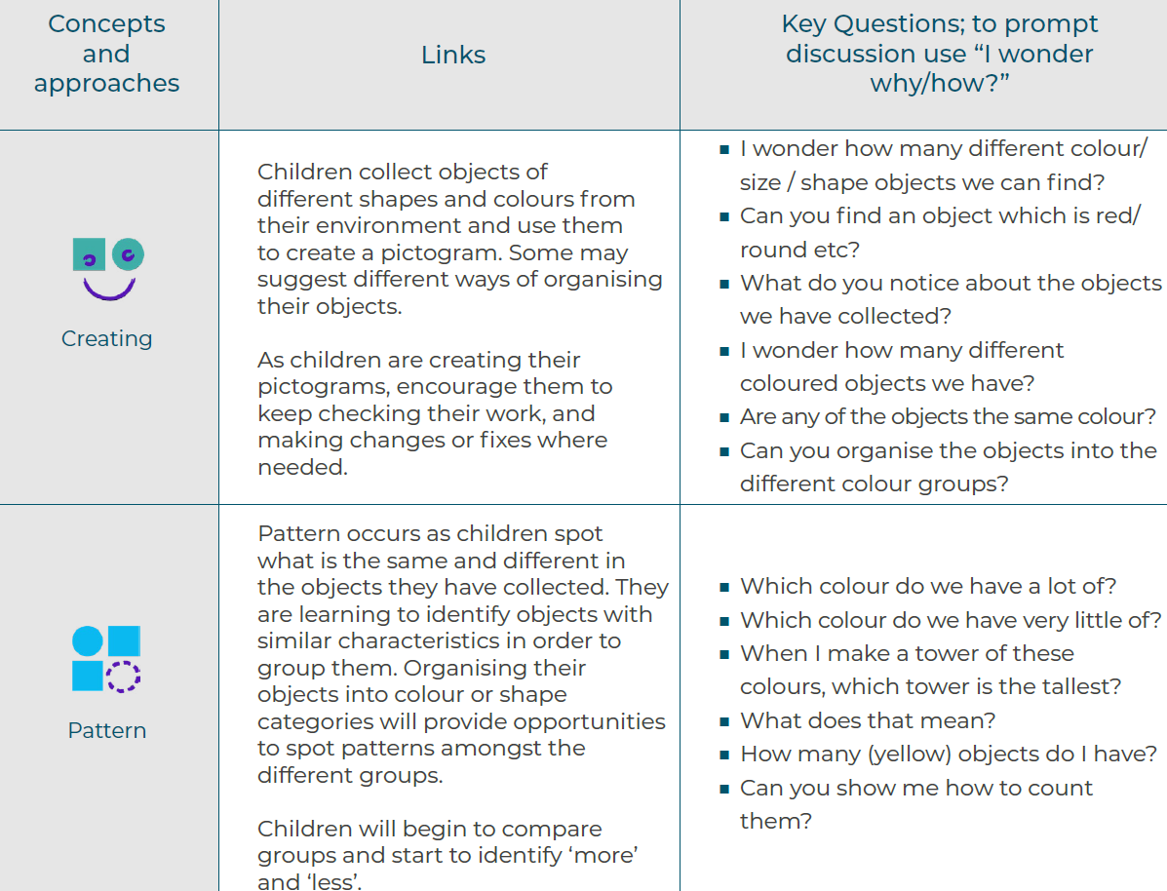  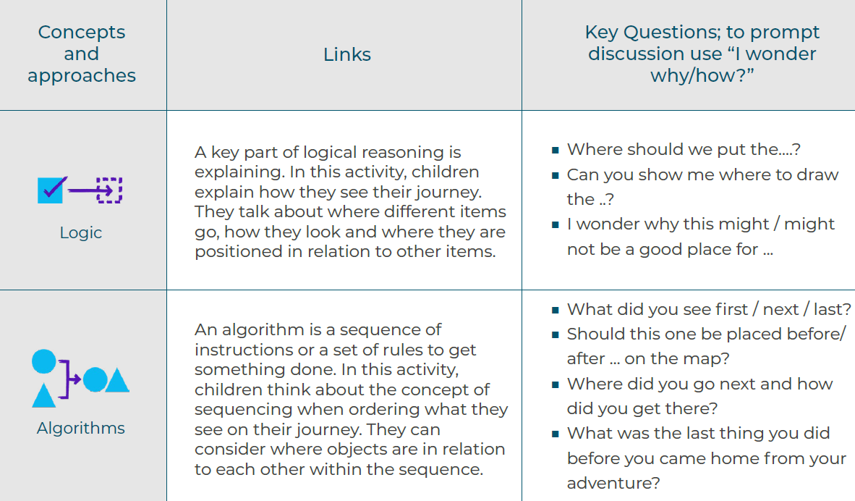 | Collections  In this activity we will be looking at developing an understanding of collecting, organising and  grouping objects.  Journey’s  Children will be encouraged to develop their own map to record things they might see whilst on a journey  or walk, such as to the park, in a car or on a bus etc. (imaginary or real). Children can take photographs or  make a list, with support, of the things they see e.g.- trees, shops, parks, buildings, animals, etc. Children  will be supported in adding drawings, sketches, and toys to a large sketched out road on a large piece of  paper.  Tangrams  In this activity the children will be prompted by looking at some seaside pictures and  identifying the shapes they can see that might help form some of the familiar objects  such as the lighthouse, boats, etc. They will be encouraged to name common 2D shapes  and experiment with how they can combine shapes to create their own seaside picture.
Summer 2 | IT Photography  I know what a photo is and that is a printed image not a drawing.  I can take photos using a digital device eg KITT or an ipad.  I know that I need to ask for consent to take a photo of a person.  Introduction to data  I know how to sort physical objects into 2 categories.  I can sort physical objects, take a picture and discuss what I have done.  Purple mash: 2 count  Create a class pictogram (use the emotions images to ask the children how they are feeling today). | Ensure children know what a photo is and what devices can take photos.  *talk about taking photos of each other, people and friends and that you must always ask for permission. Can I take your photo please?  Use IPads to take photos of set objects, view an image. Take images  Recap sorting into categories. Children can use an ipad to take a photo of their sorting and talk about it.  Create a class pictogram of emotions (or topic related images). Children should be able to answer simple questions eg how many smily faces have we. The children should eb able to tell you to click and drag images and how to save and exit etc.. | Ipad camera  Mashcams  2count | Photo  Permission  Click  Delete  Sort  Count  How many  Click  Drag  Mouse/ pointer/keyboard  Save  Log on and log out.

