Knowledge Progression in Computing
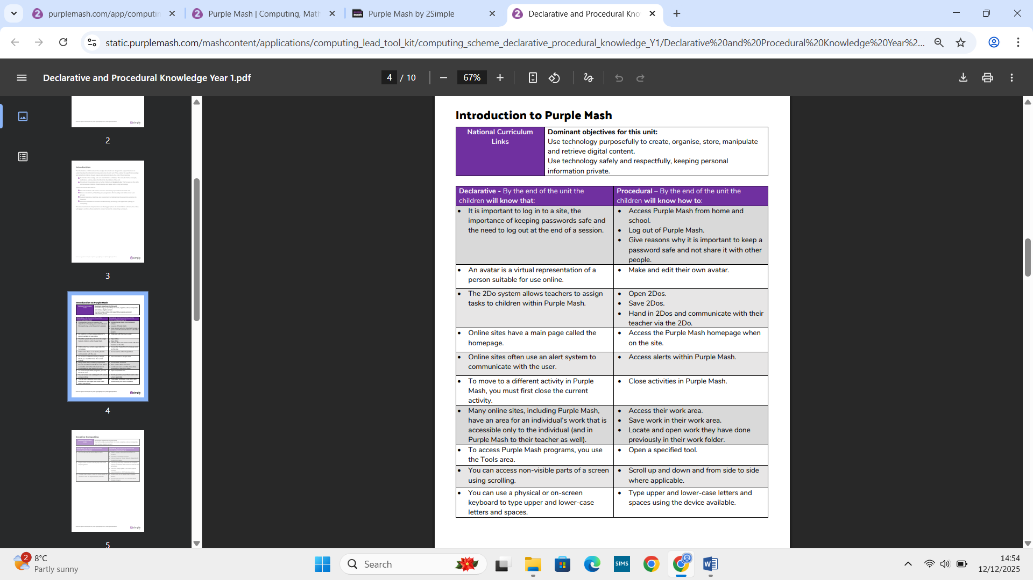
YEAR 1

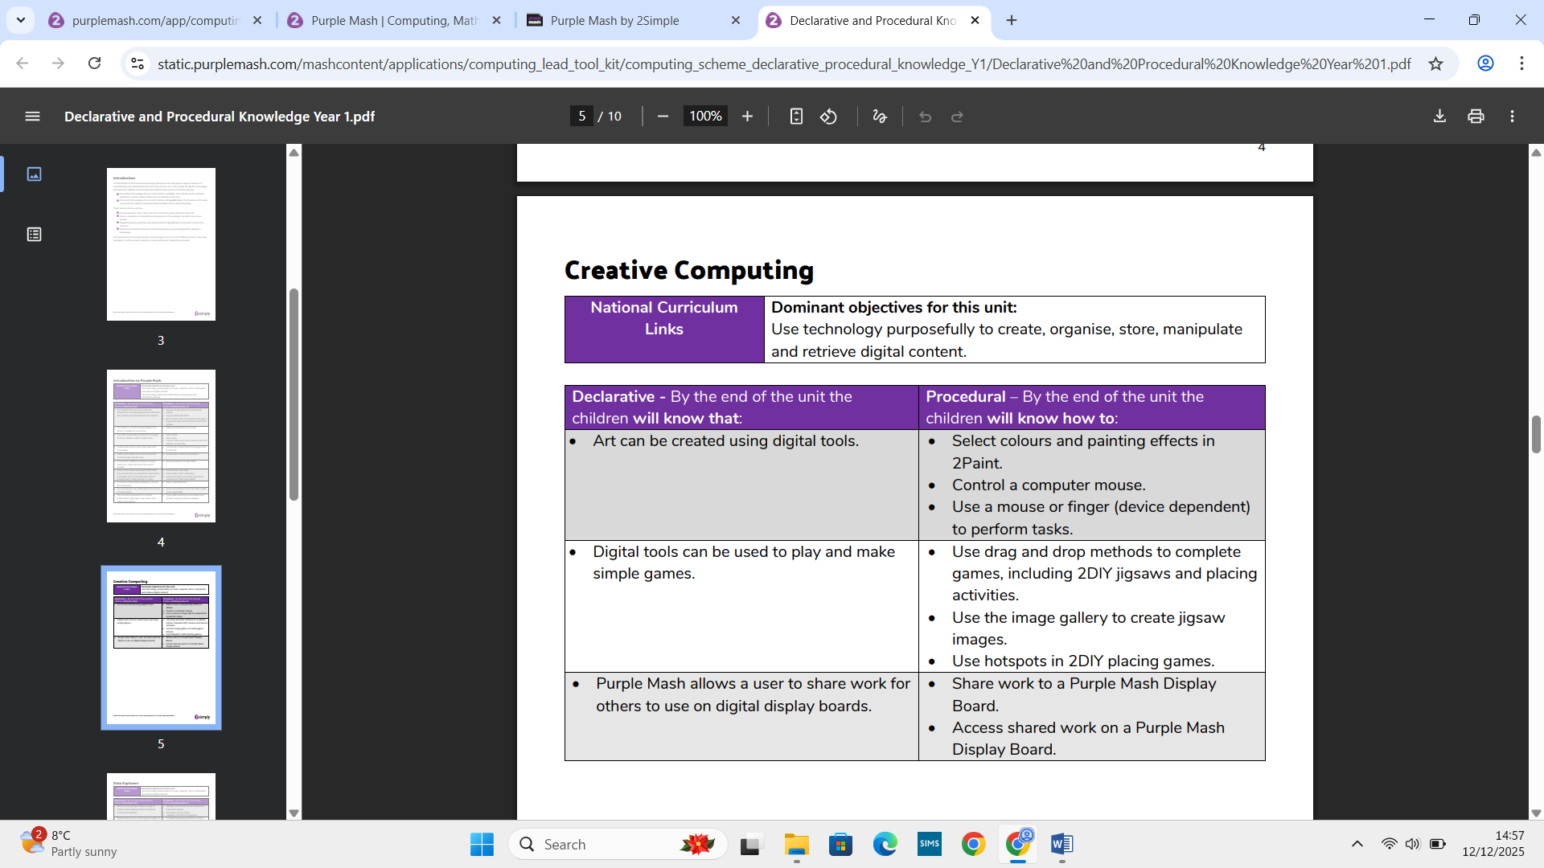

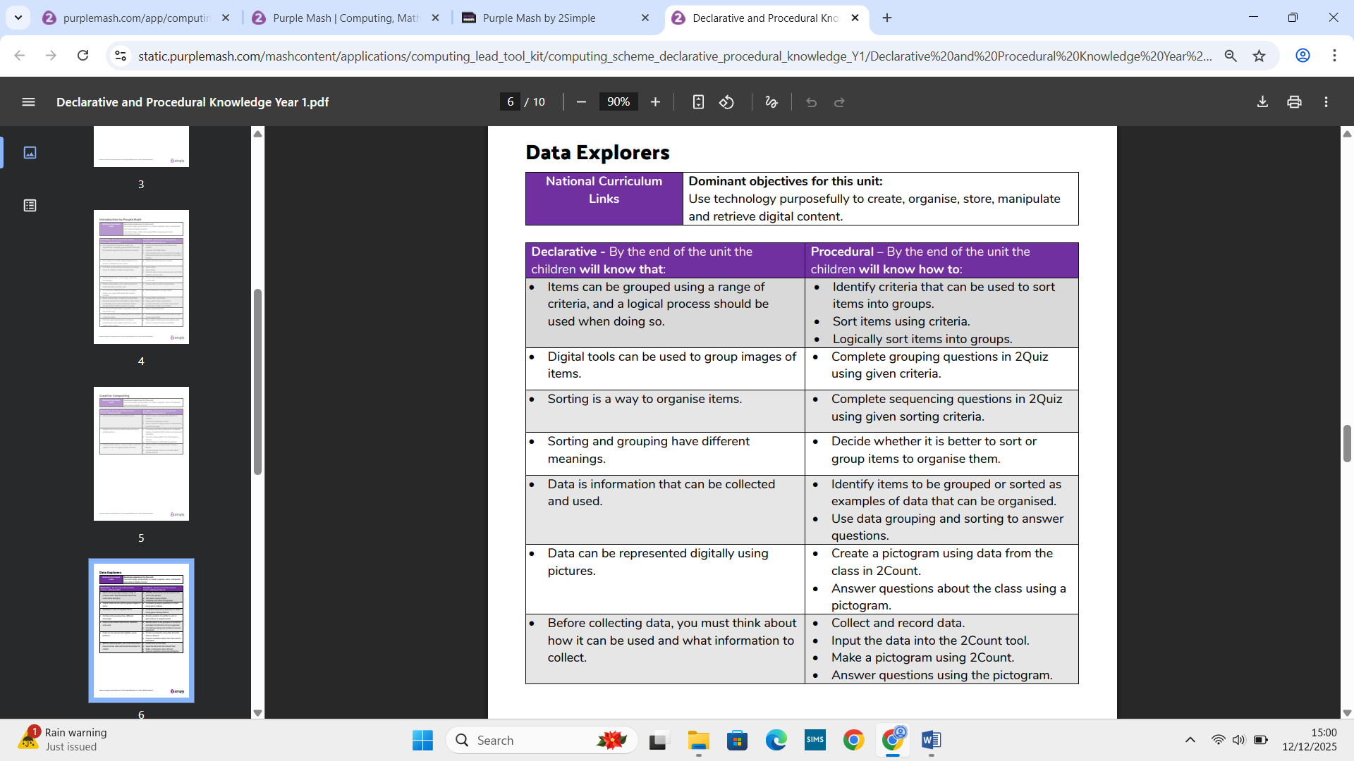

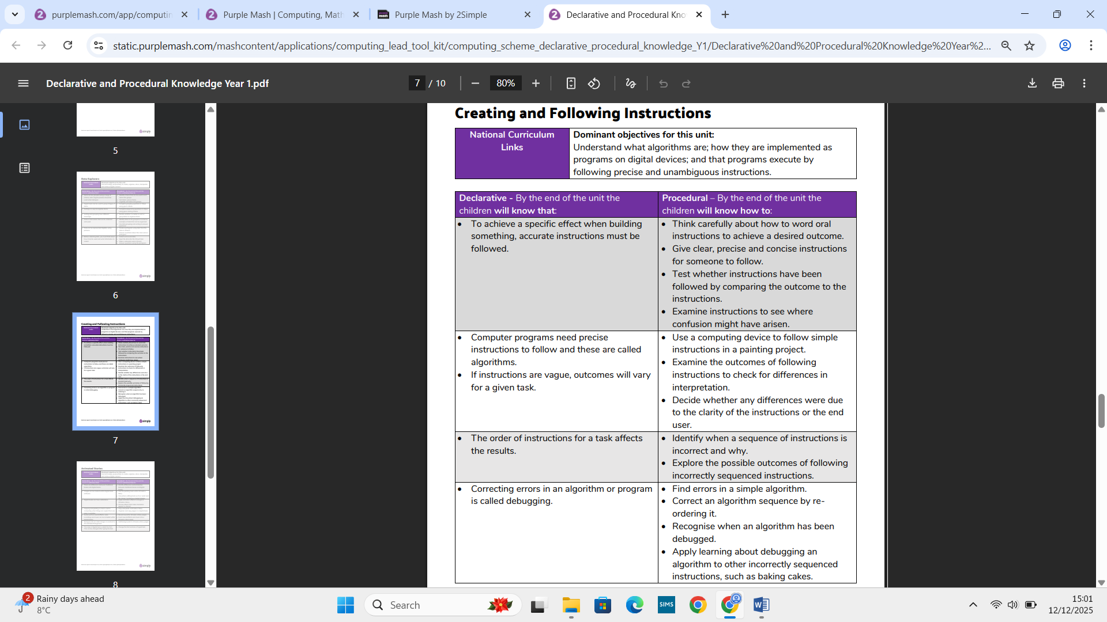

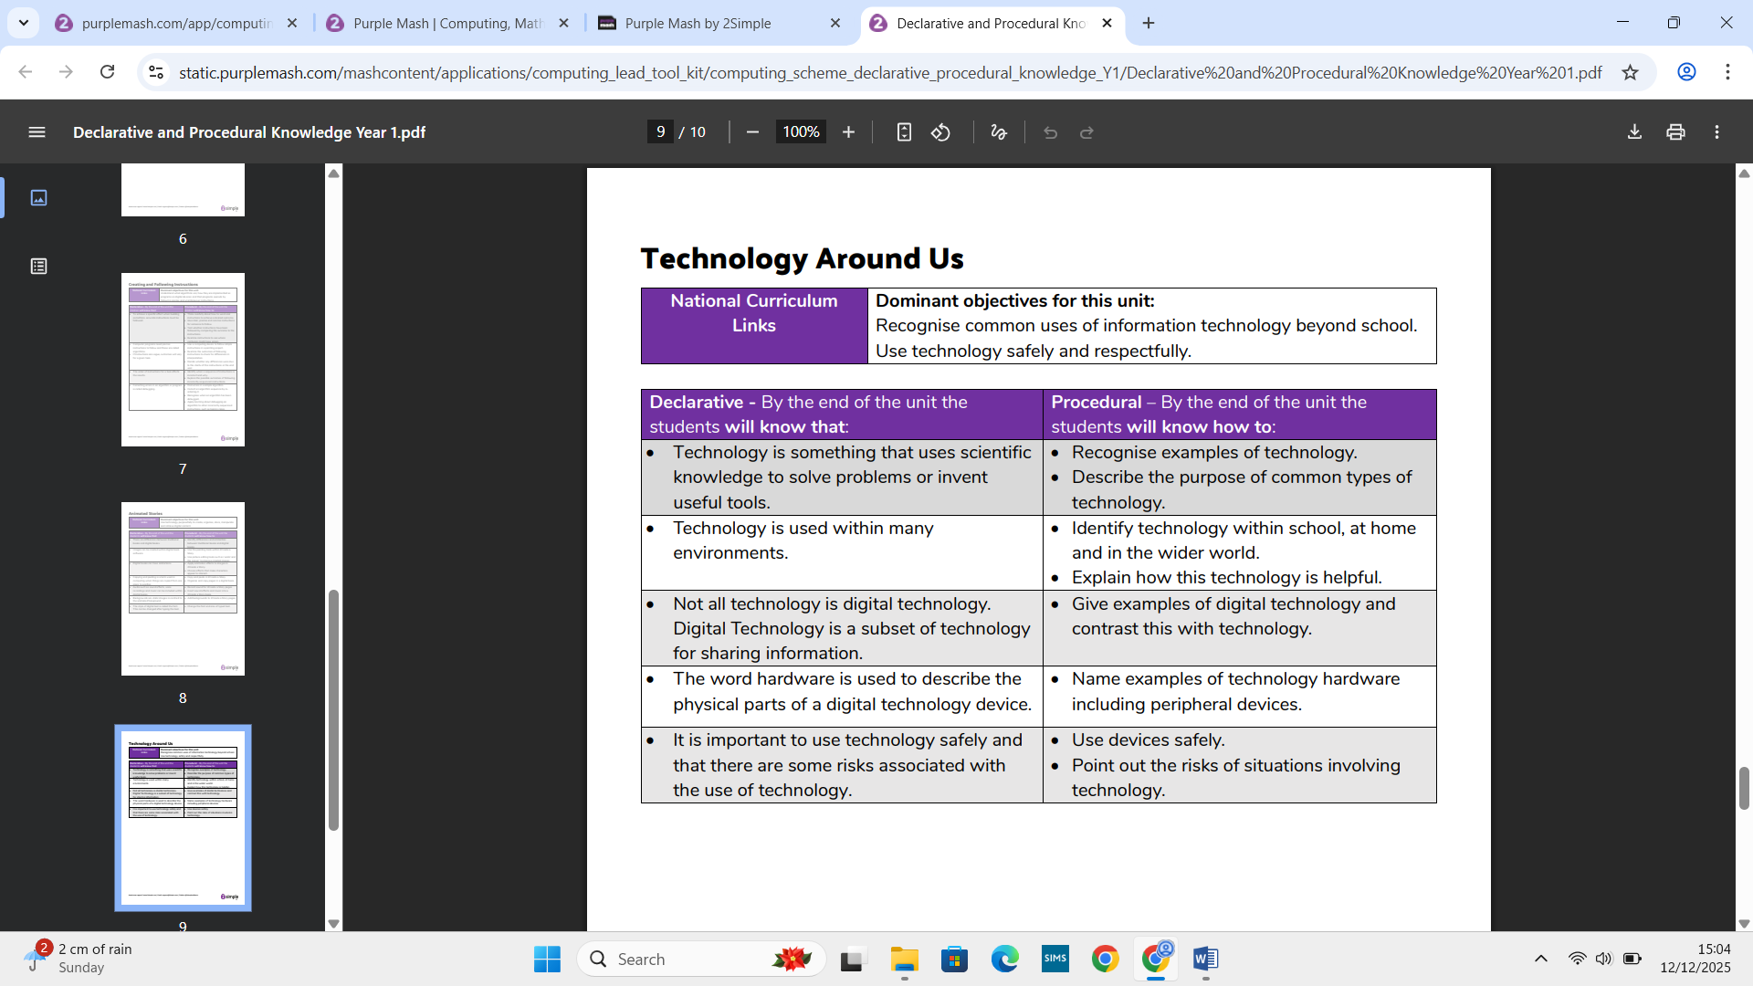

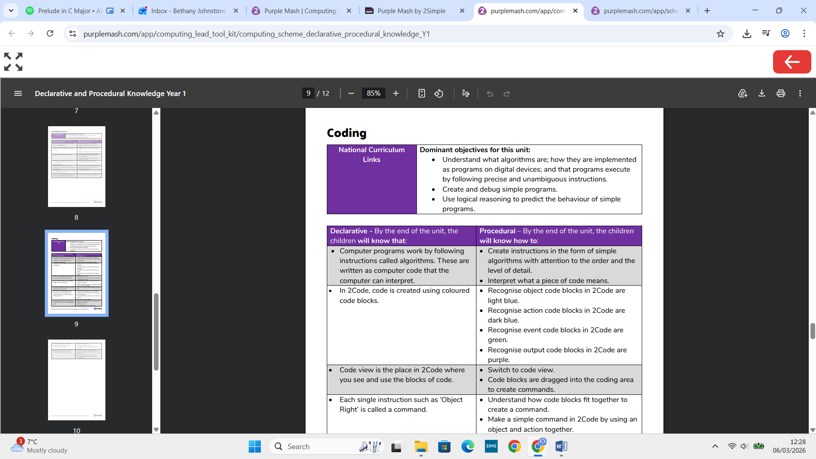

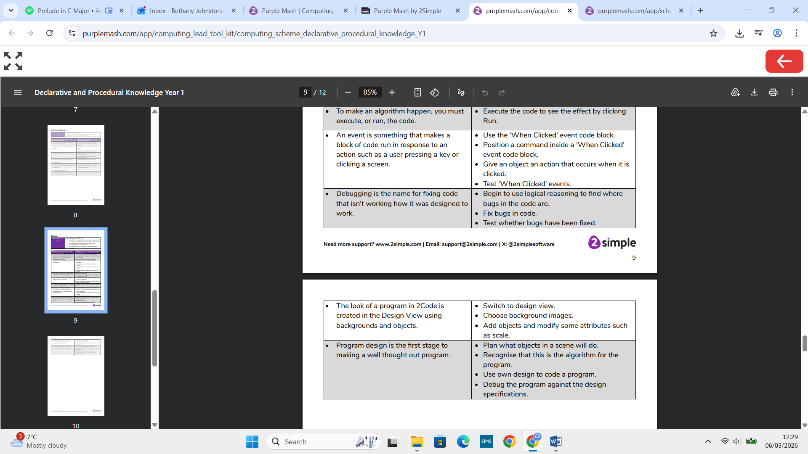

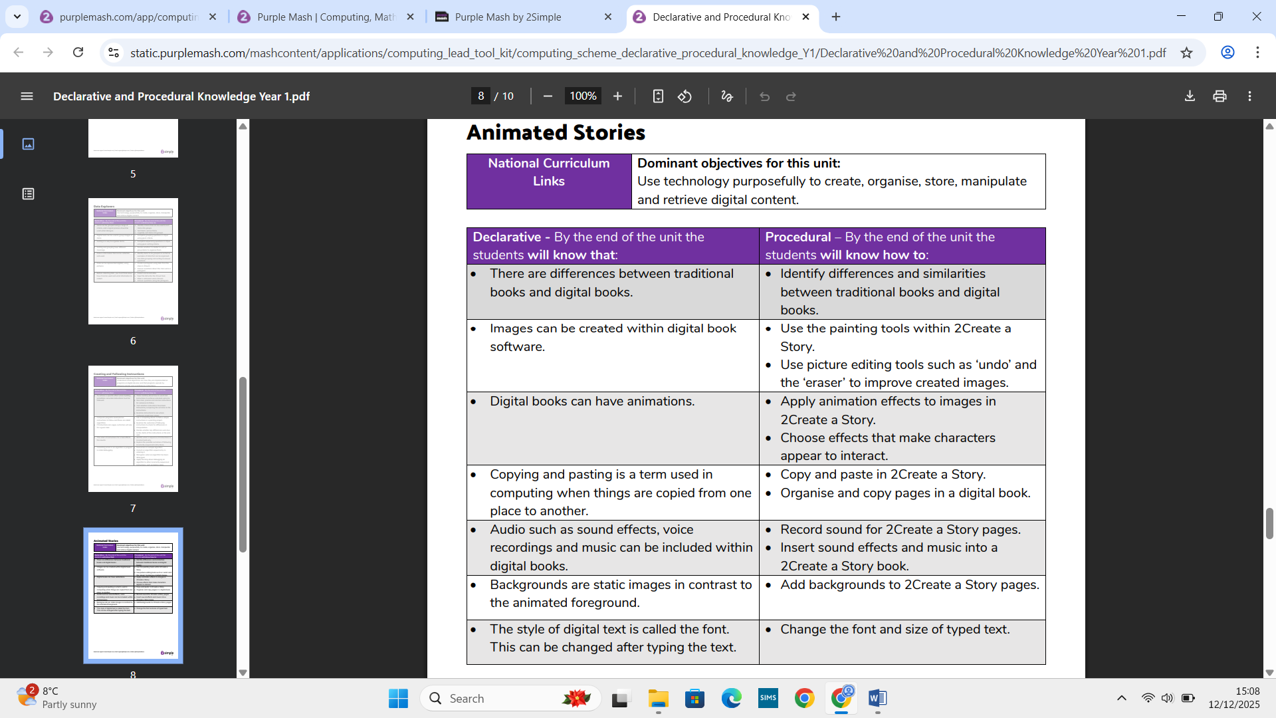

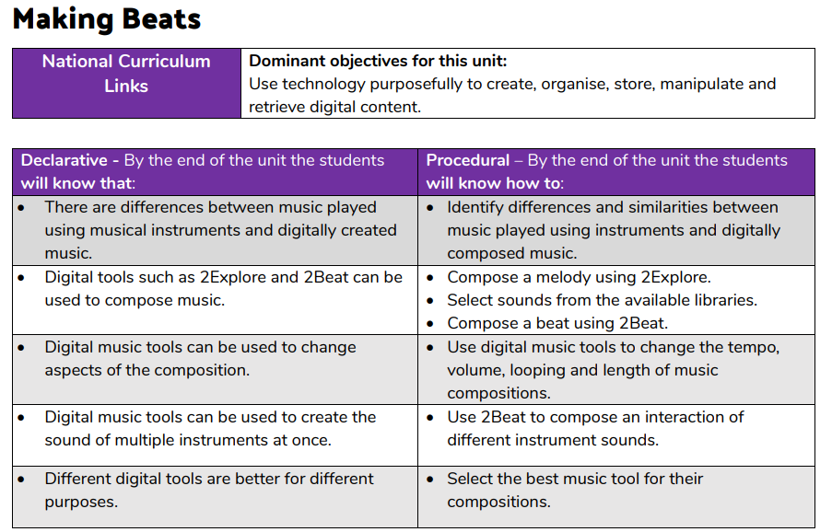

Year 2
NCCE Taking photographs
NATIONAL CURRICULUM LINKS | National curriculum computing links  Computing  - Use technology purposefully to create, organise, store, manipulate, and retrieve digital content  - Recognise common uses of information technology beyond school  - Use technology safely and respectfully, keeping personal information private; identify where to go for help and support when they have concerns about content or contact on the internet or other online technologies

Declarative - By the end of the unit the students will know that: | Procedural – By the end of the unit the students will know how to:
I can recognise what devices can be used to take photographs  I can talk about how to take a photograph  I can explain what I did to capture a digital photo  I can explain the process of taking a good photograph  I can explain why a photo looks better in portrait or landscape format | I can take photos in both landscape and portrait format
I can identify what is wrong with a photograph  I can discuss how to take a good photograph | I can improve a photograph by retaking it
I can explore the effect that light has on a photo  I can experiment with different light sources  I can explain why a picture may be unclear  I can recognise that images can be changed  I can explain my choices  I can recognise which photos have been changed  I can identify which photos are real and which have been changed | I can use a tool to achieve a desired effect  I can apply a range of photography skills to capture a photo

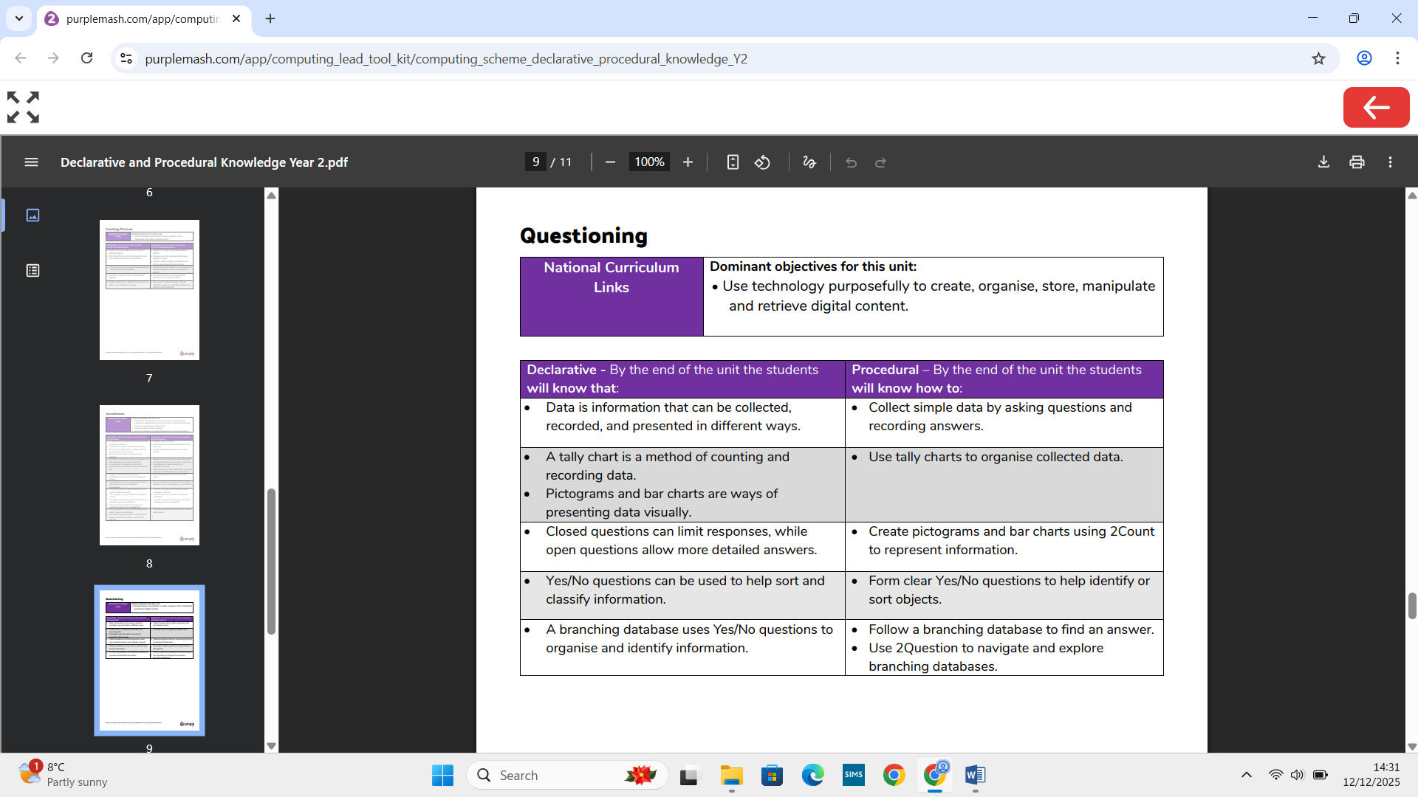
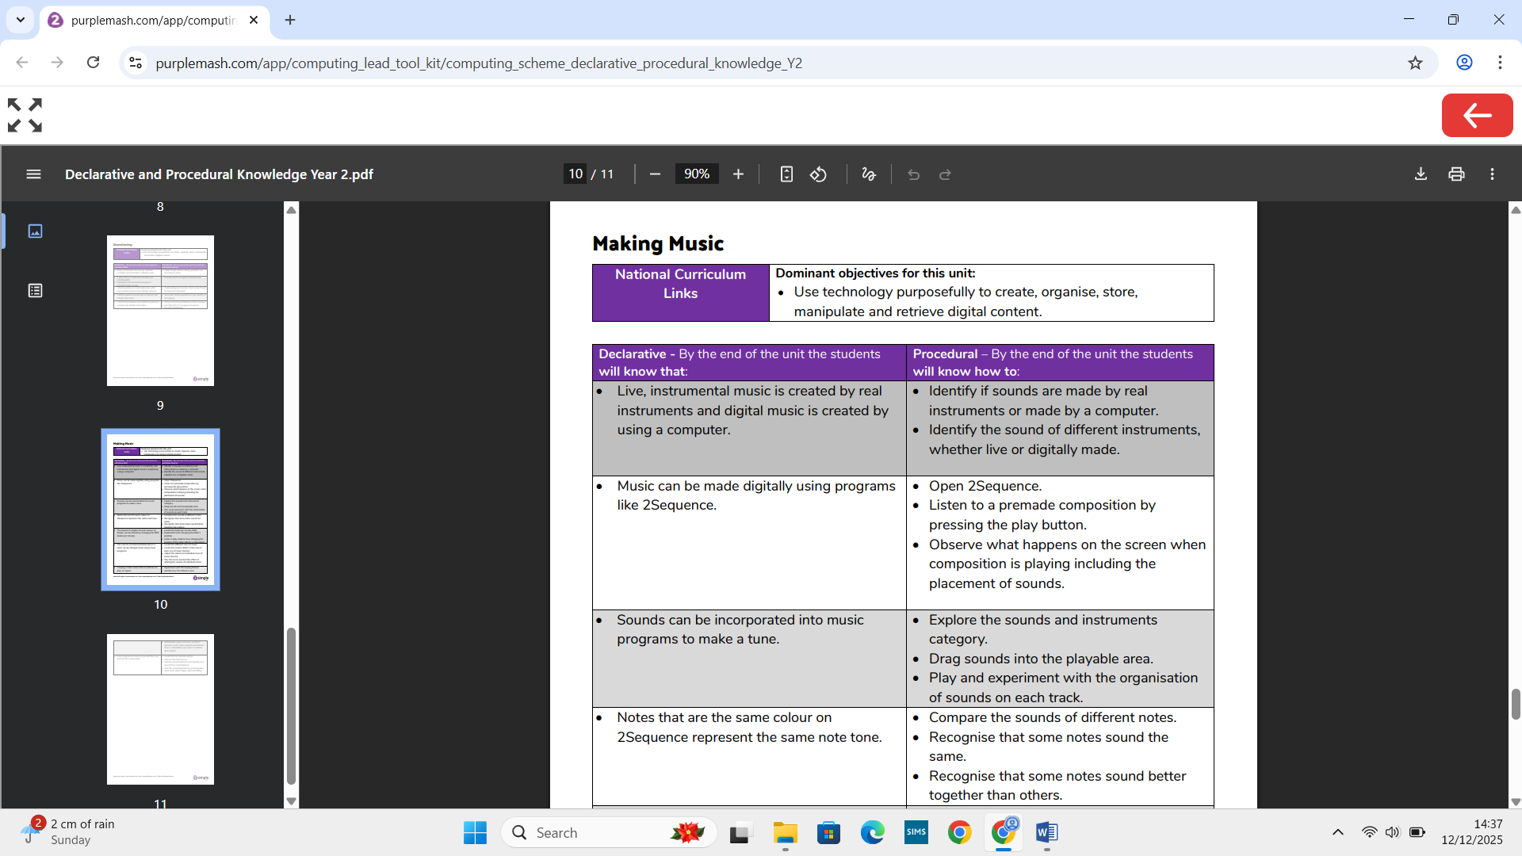
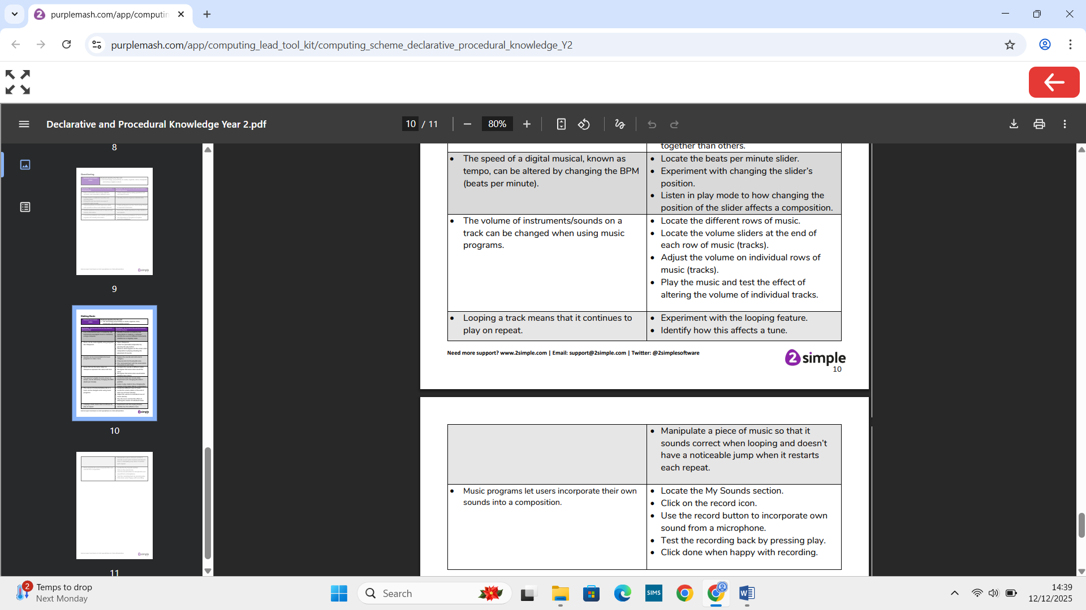

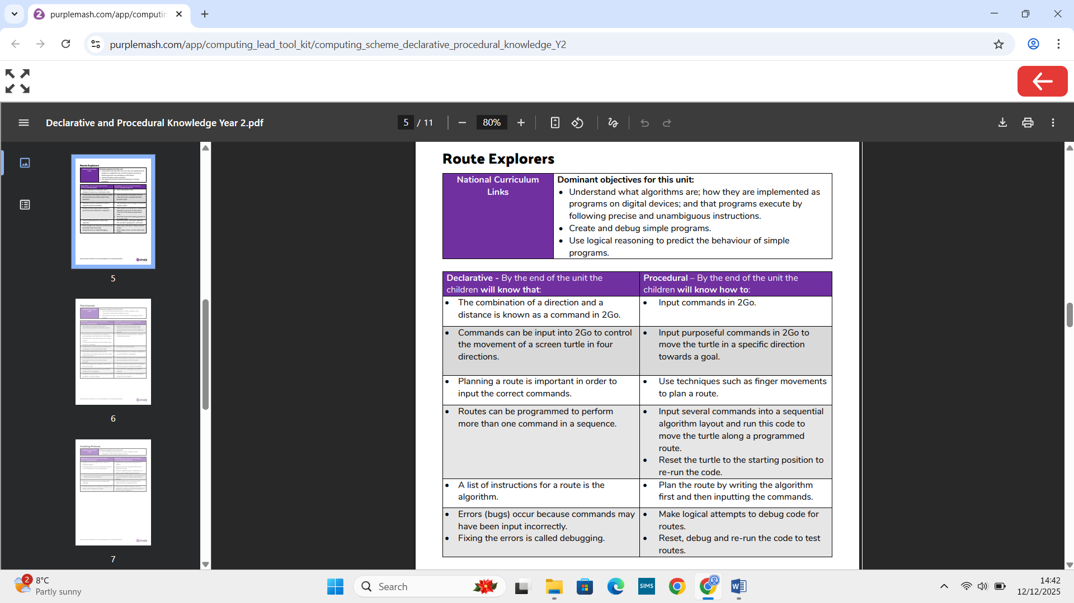

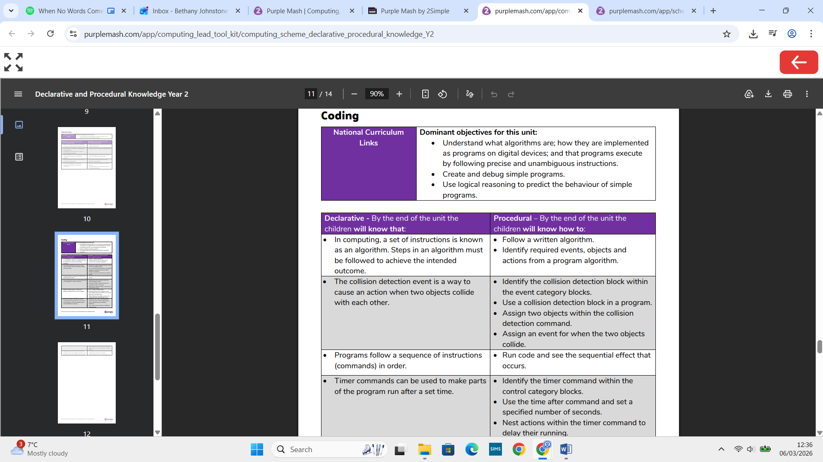

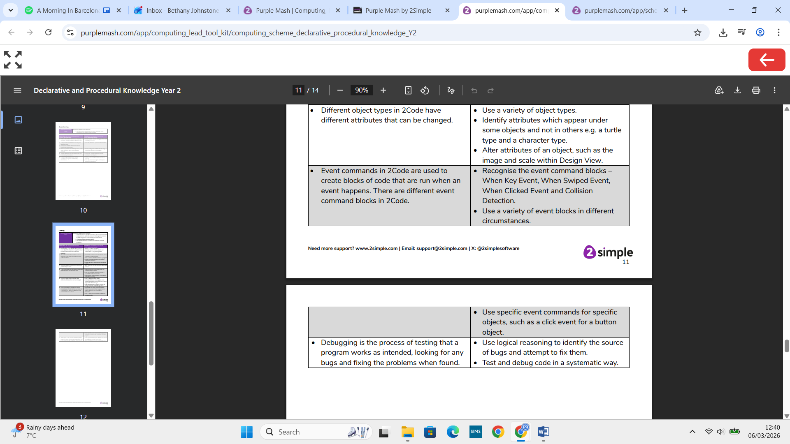

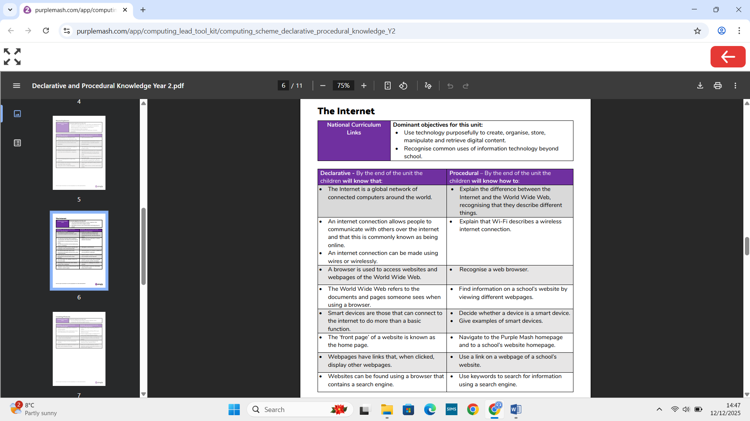

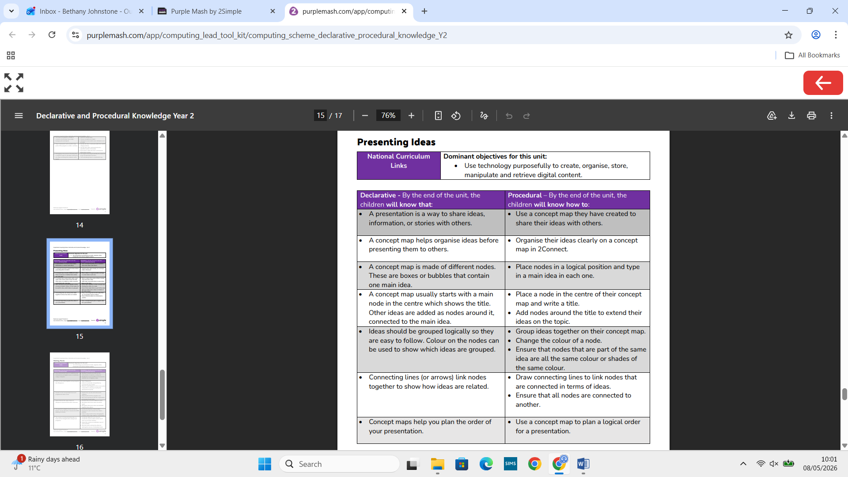

Word Processing
NATIONAL CURRICULUM LINKS

Declarative - By the end of the unit the students will know that: | Procedural – By the end of the unit the students will know how to:

